1. When you open the site it has to show following page

(Please use different font styles, sizes, colors and etc, it should not be like a gmail. Apply your own creativity)

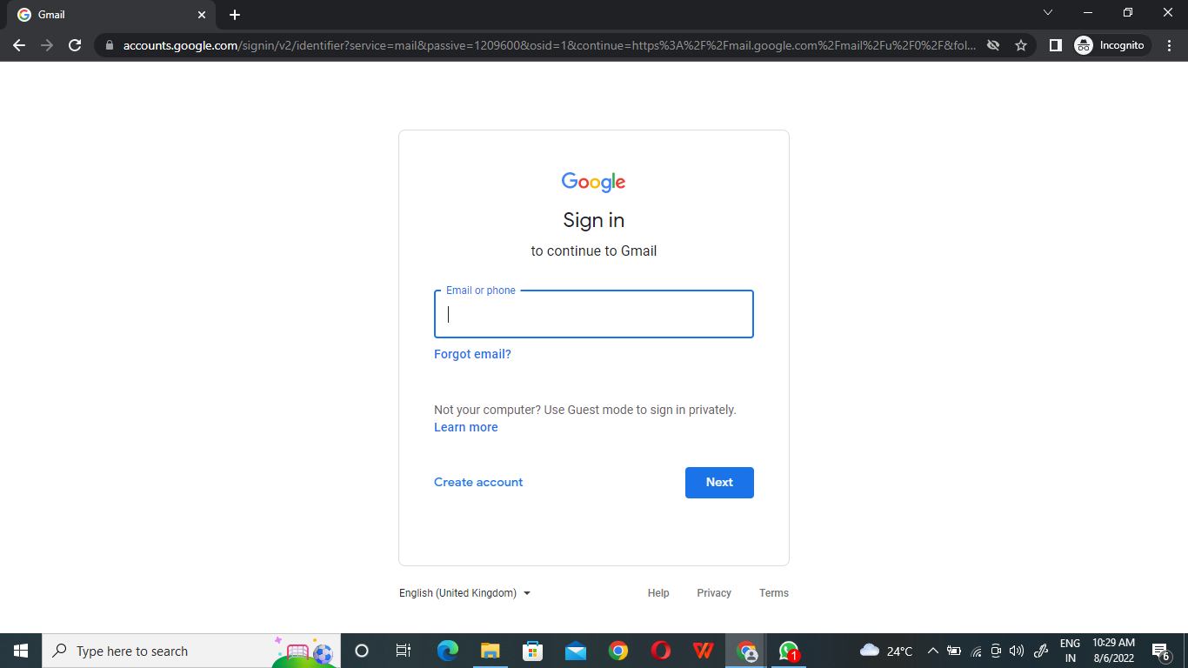

2. From above page if we select “Create account”, it has to show following page

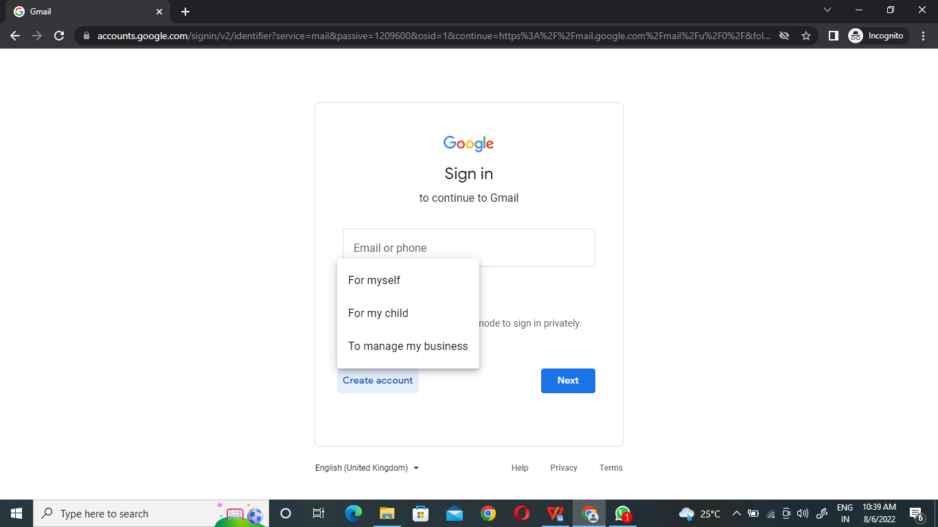

1. From above page if we select “For myself”, it has to show following page

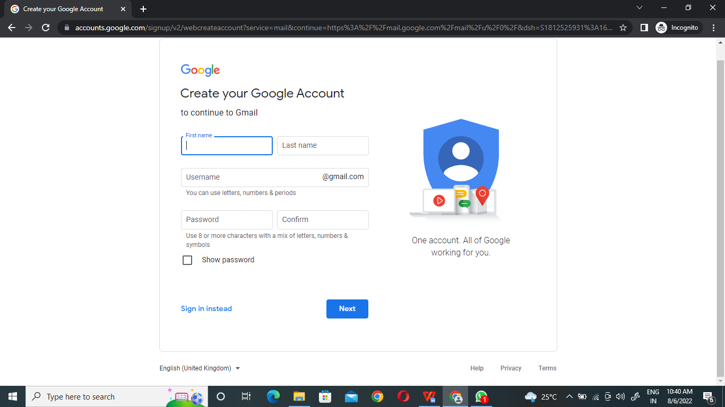

1. In the above page, enter valid details and click “Next” button, then it has to show following page

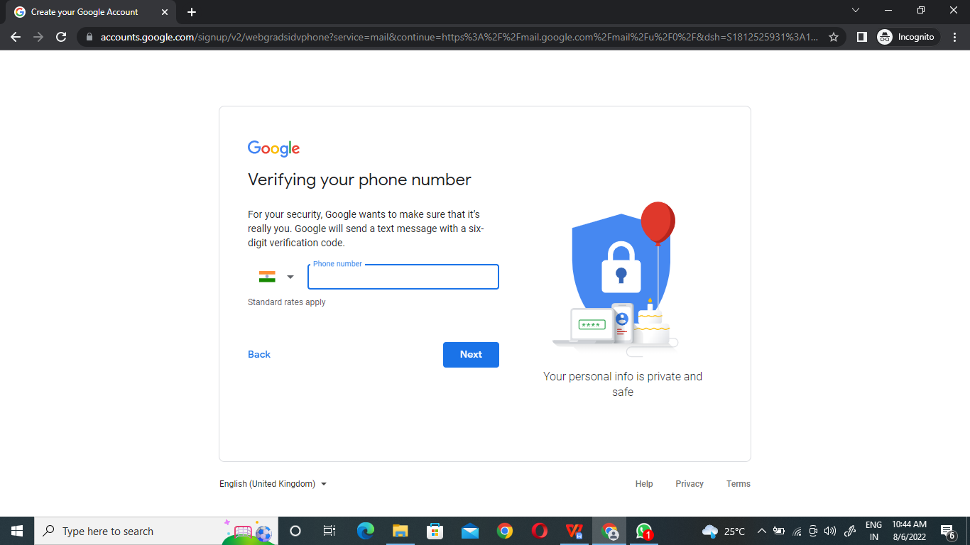

1. From above page enter valid 10 digits mobile number, click “Next” Button, then it has to show following page

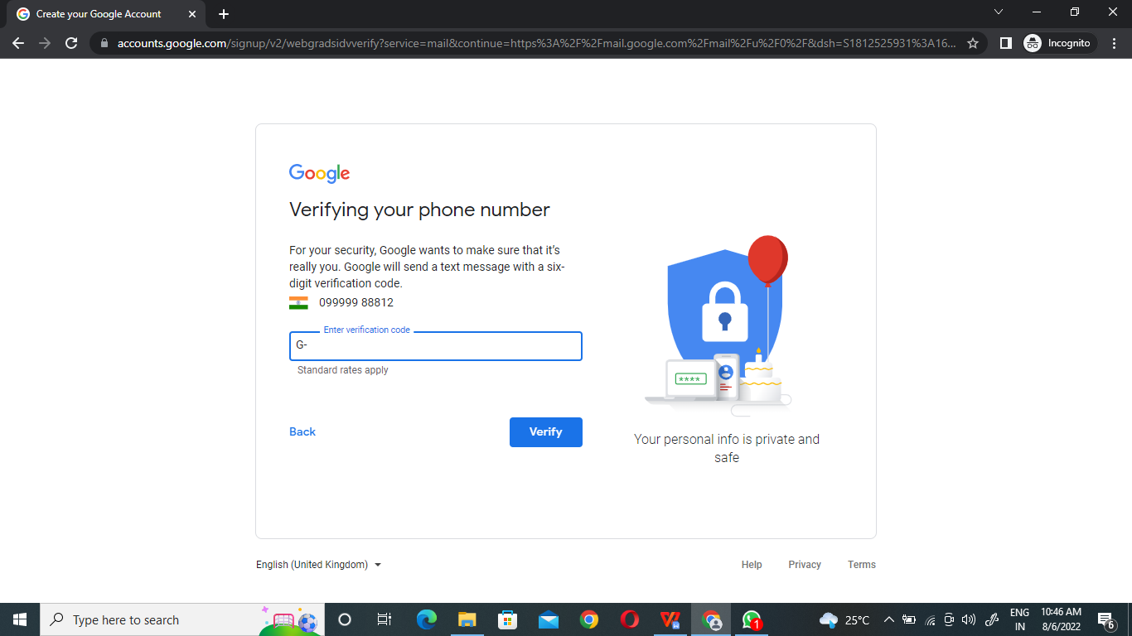

Lets continue from step 1

1. When you open the site it has to show following page



1. From above page enter valid Email and password, then it has to show following page

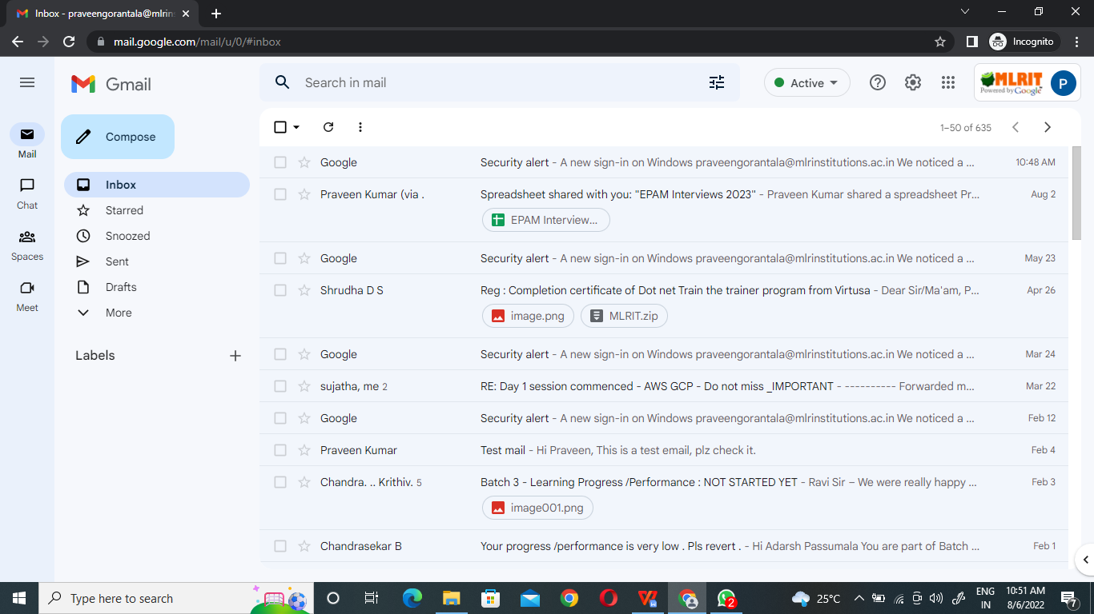

**If you want to add any extra functionality you can add, that will be appreciated.**